let resume= {

name:"Sivani S S",

contactDetails:{

    phoneNumber:"787989898978",

    emailId:"rednaz.inavis@gmail.com"

},

address:{

    no :"17",

    street:"1st cross street,Dhanalakshmi Nagar",

    city:"Chennai",

    pincode:"600073"

},

jobObjective:"An aspiring engineer having two years of experience and aiming to deliver superior performance with my innovative ideas , troubleshooting skills , management techniques  for the sustained growth of self and company",

academicProfile:{

    sslc:{ins:"Zion Matriculation Higher Secondary School,",board:"State Board",marks:"98.2"},

    hs:{ins:"Zion Matriculation Higher Secondary School,",board:"State Board",marks:"96.1"},

    college:{ins:"St.Josephs College of Engineering",board:"Anna University",marks:"82"}

},

skills:{

    languageAndSkills:"AWS , Java , HTML ,Microsoft Office Word , Microsoft Office PowerPoint , Microsoft Office Excel.",

    os:"Windows 10, CentOS(linux)",

    database:"MySQl"

},

academicActivities:{

    inplantTraining:" Networking at BSNL Technologies, Chennai",

    courses:      " 1) Received Grade C in Business English by Cambridge English Language Assessment \n 2) NPTEL Online Certification for the course IMAD(Introduction to Modern Application and Development) with a score of 67%  in the period of June 2017 -Sep 2017 \n 3) Completed 'Ultimate  AWS Certified Solutions Architect Associate 2021' course from Udemy."

},

careerPath:{

    current:"TATA CONSULTANCY SERVICES(TCS) – August 2019 to current in Enterprise Cognitive Technologies Group \n 1) Actifio (Backup and restore tool) : Completed five actifio certifications. Worked in deployment of the tool in VM and cloud platforms like AWS , Configuring backups for different platforms , Monitoring the backups and preparing daily reports, Performing troubleshooting operations. \n 2) Opsview (Network Monitoring tool) : Worked on deployment of the tool in linux VMs , Configuring  service checks for Windows VM, linux VM , mysql database , websites. Configured event handlers to restart a service when it goes down. \n 3) Completed basic training on Networking Switching and Routing. \n 4) Worked on Cisco Meraki on available devices , models , license types and implementing use cases \n 5)   Worked on creating solutions/bill of materials  for data centers of various accounts based on their requirements."

    ,

    internship:" Internship Program by Infosys in the period of December 2019 – April 2019 "

},

projects:" 1) One of the three developers of a web app ‘BUGFIX’ which is a simple game based on debugging code where players can bid their points to attempt a question according on its difficulty. \n 2) Developed an angular website which displays list of google contacts and youtube subscribers of the logged in google user and shows the common users and list of suggested channels to be followed and helps to keep track of users."

,

strengths:" 1) Strong determination to succeed and excel \n 2) Well rounded interests and good communication skills \n 3) Goal driven and ability to work hard \n 4) Flexibility to adapt to different environment ",

hobbies:" 1) Cooking \n 2) Numismatics \n 3) Illustration and designing - https://dribbble.com/Inavis",

personalDetails:{

    dob:"22/05/1998",

    fatherName:"Saravanan B",

    motherName:"Sutha S",

    langaugesKnown:"English, Tamil , Telugu (spoken)"

}

};

console.log(resume);

let data= `

                                         RESUME

Name: ${resume.name}

Contact:

Phone number: ${resume.contactDetails.phoneNumber}

Email address: ${resume.contactDetails.emailId}

Address:

No. : ${resume.address.no}

Street: ${resume.address.street}

City: ${resume.address.city}

Pincode: ${resume.address.pincode}

Job objective:

${resume.jobObjective}

Academic profile:

High school: Name: ${resume.academicProfile.sslc.ins} Board: ${resume.academicProfile.sslc.board} Marks: ${resume.academicProfile.sslc.marks}

Higher secondary: Name: ${resume.academicProfile.hs.ins} Board: ${resume.academicProfile.hs.board} Marks: ${resume.academicProfile.hs.marks}

College: Name: ${resume.academicProfile.college.ins} Board: ${resume.academicProfile.college.board} Marks: ${resume.academicProfile.college.marks}

Skills:

Language and Skills: ${resume.skills.languageAndSkills}

Operating system: ${resume.skills.os}

Database: ${resume.skills.database}

Academic activities:

Inplant training:

${resume.academicActivities.inplantTraining}

Courses:

${resume.academicActivities.courses}

Career Path:

Current:

${resume.careerPath.current}

Internship:

${resume.careerPath.internship}

Project:

${resume.projects}

Strength:

${resume.strengths}

Hobbies:

${resume.hobbies}

Personal Details:

Date of Birth: ${resume.personalDetails.dob}

Father's name: ${resume.personalDetails.fatherName}

Mother's name: ${resume.personalDetails.motherName}

Languages known: ${resume.personalDetails.langaugesKnown}

`;

console.log(data);

OUTPUT:

**Image:**

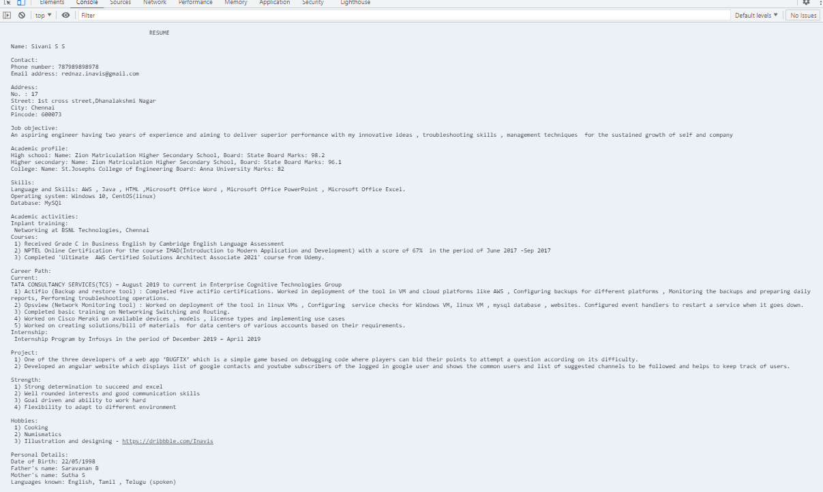

**From Console:**

RESUME

Name: Sivani S S

Contact:

Phone number: 787989898978

Email address: rednaz.inavis@gmail.com

Address:

No. : 17

Street: 1st cross street,Dhanalakshmi Nagar

City: Chennai

Pincode: 600073

Job objective:

An aspiring engineer having two years of experience and aiming to deliver superior performance with my innovative ideas , troubleshooting skills , management techniques for the sustained growth of self and company

Academic profile:

High school: Name: Zion Matriculation Higher Secondary School, Board: State Board Marks: 98.2

Higher secondary: Name: Zion Matriculation Higher Secondary School, Board: State Board Marks: 96.1

College: Name: St.Josephs College of Engineering Board: Anna University Marks: 82

Skills:

Language and Skills: AWS , Java , HTML ,Microsoft Office Word , Microsoft Office PowerPoint , Microsoft Office Excel.

Operating system: Windows 10, CentOS(linux)

Database: MySQl

Academic activities:

Inplant training:

Networking at BSNL Technologies, Chennai

Courses:

1) Received Grade C in Business English by Cambridge English Language Assessment

2) NPTEL Online Certification for the course IMAD(Introduction to Modern Application and Development) with a score of 67% in the period of June 2017 -Sep 2017

3) Completed 'Ultimate AWS Certified Solutions Architect Associate 2021' course from Udemy.

Career Path:

Current:

TATA CONSULTANCY SERVICES(TCS) – August 2019 to current in Enterprise Cognitive Technologies Group

1) Actifio (Backup and restore tool) : Completed five actifio certifications. Worked in deployment of the tool in VM and cloud platforms like AWS , Configuring backups for different platforms , Monitoring the backups and preparing daily reports, Performing troubleshooting operations.

2) Opsview (Network Monitoring tool) : Worked on deployment of the tool in linux VMs , Configuring service checks for Windows VM, linux VM , mysql database , websites. Configured event handlers to restart a service when it goes down.

3) Completed basic training on Networking Switching and Routing.

4) Worked on Cisco Meraki on available devices , models , license types and implementing use cases

5) Worked on creating solutions/bill of materials for data centers of various accounts based on their requirements.

Internship:

Internship Program by Infosys in the period of December 2019 – April 2019

Project:

1) One of the three developers of a web app ‘BUGFIX’ which is a simple game based on debugging code where players can bid their points to attempt a question according on its difficulty.

2) Developed an angular website which displays list of google contacts and youtube subscribers of the logged in google user and shows the common users and list of suggested channels to be followed and helps to keep track of users.

Strength:

1) Strong determination to succeed and excel

2) Well rounded interests and good communication skills

3) Goal driven and ability to work hard

4) Flexibility to adapt to different environment

Hobbies:

1) Cooking

2) Numismatics

3) Illustration and designing - https://dribbble.com/Inavis

Personal Details:

Date of Birth: 22/05/1998

Father's name: Saravanan B

Mother's name: Sutha S

Languages known: English, Tamil , Telugu (spoken)